**Nama : Galfin Muzani Syukur (1127050063)**

**Sigit Husen Munadi (1127050142)**

**Kelas : IF/ V/ G**

Sequence diagram

1. Pesan makanan

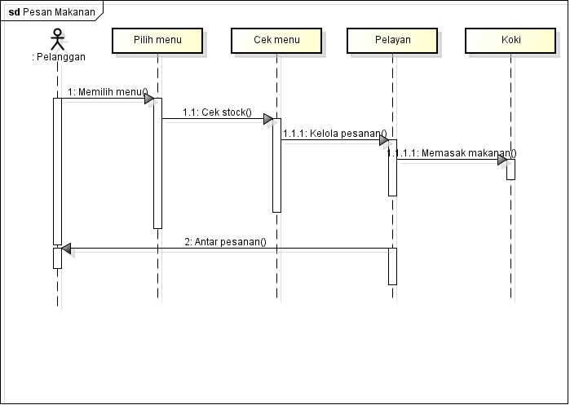

1. Tolak pesanan

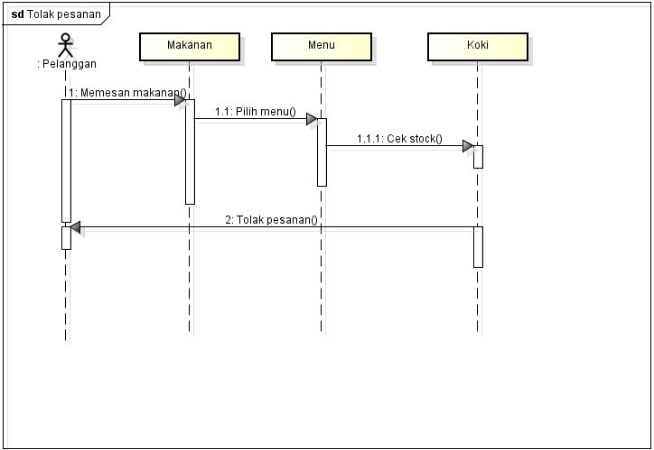

1. Kirim pesanan

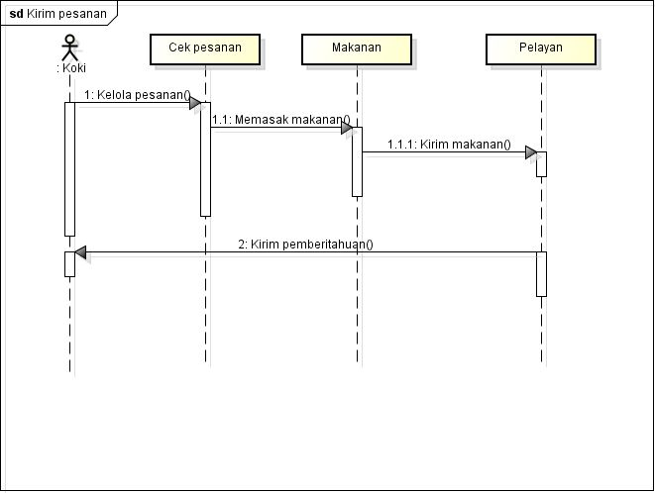

1. Antar pesanan

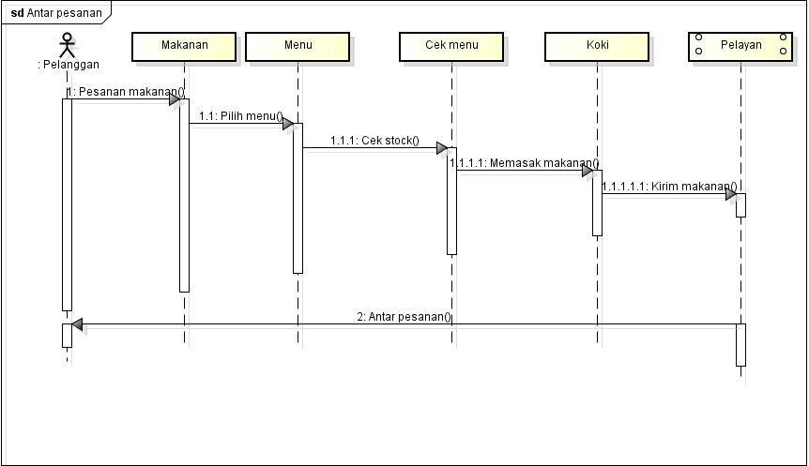

1. Antar bill

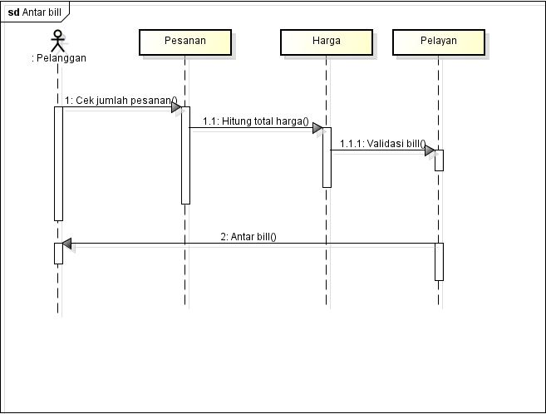

1. Bayar bill

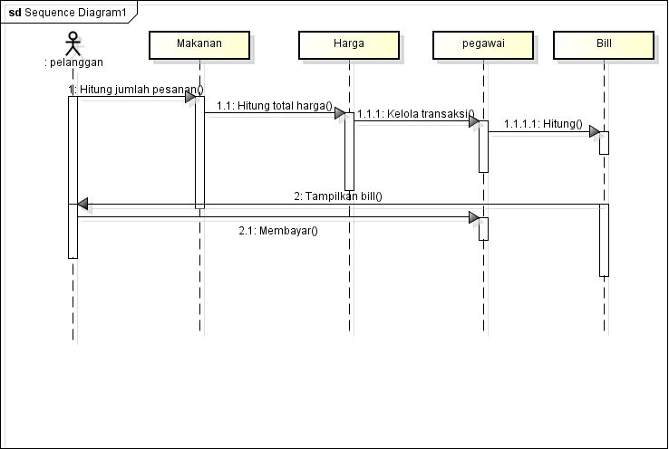

Collaboration diagram pizza

